Questions:

1. Explain how your design will be able to store the information of games, athletes and user predictions.

They are stored in an object array

2. Explain how your class hierarchy will forbid a user from creating a “generic” type of participant (i.e. not an athlete nor an official)

The user cannot create a “generic” type of participant as this is an abstract class and cannot be instantiated. It is extended by the Athlete which is also abstract and therefore no Athlete object can also be created. In order to create an object user must create objects of these classes which extend Athlete class and have concrete implementations - Swimmer, Cyclist, Sprinter, SuperAthlete.

3. Explain the process by which your program will maintain a game and give correct score to athletes according to their performance.

Within the game object, when the game is run, each athlete competes and each receive a randomly generated time (int) based on the sport they are competing in which is stored in the athlete object. The official then sorts the participants based on the ascending order of time, the time is saved in another int array (if the athlete participates in another game it will overwrite the time in its object). The points are then allocated to the first 3 athletes.

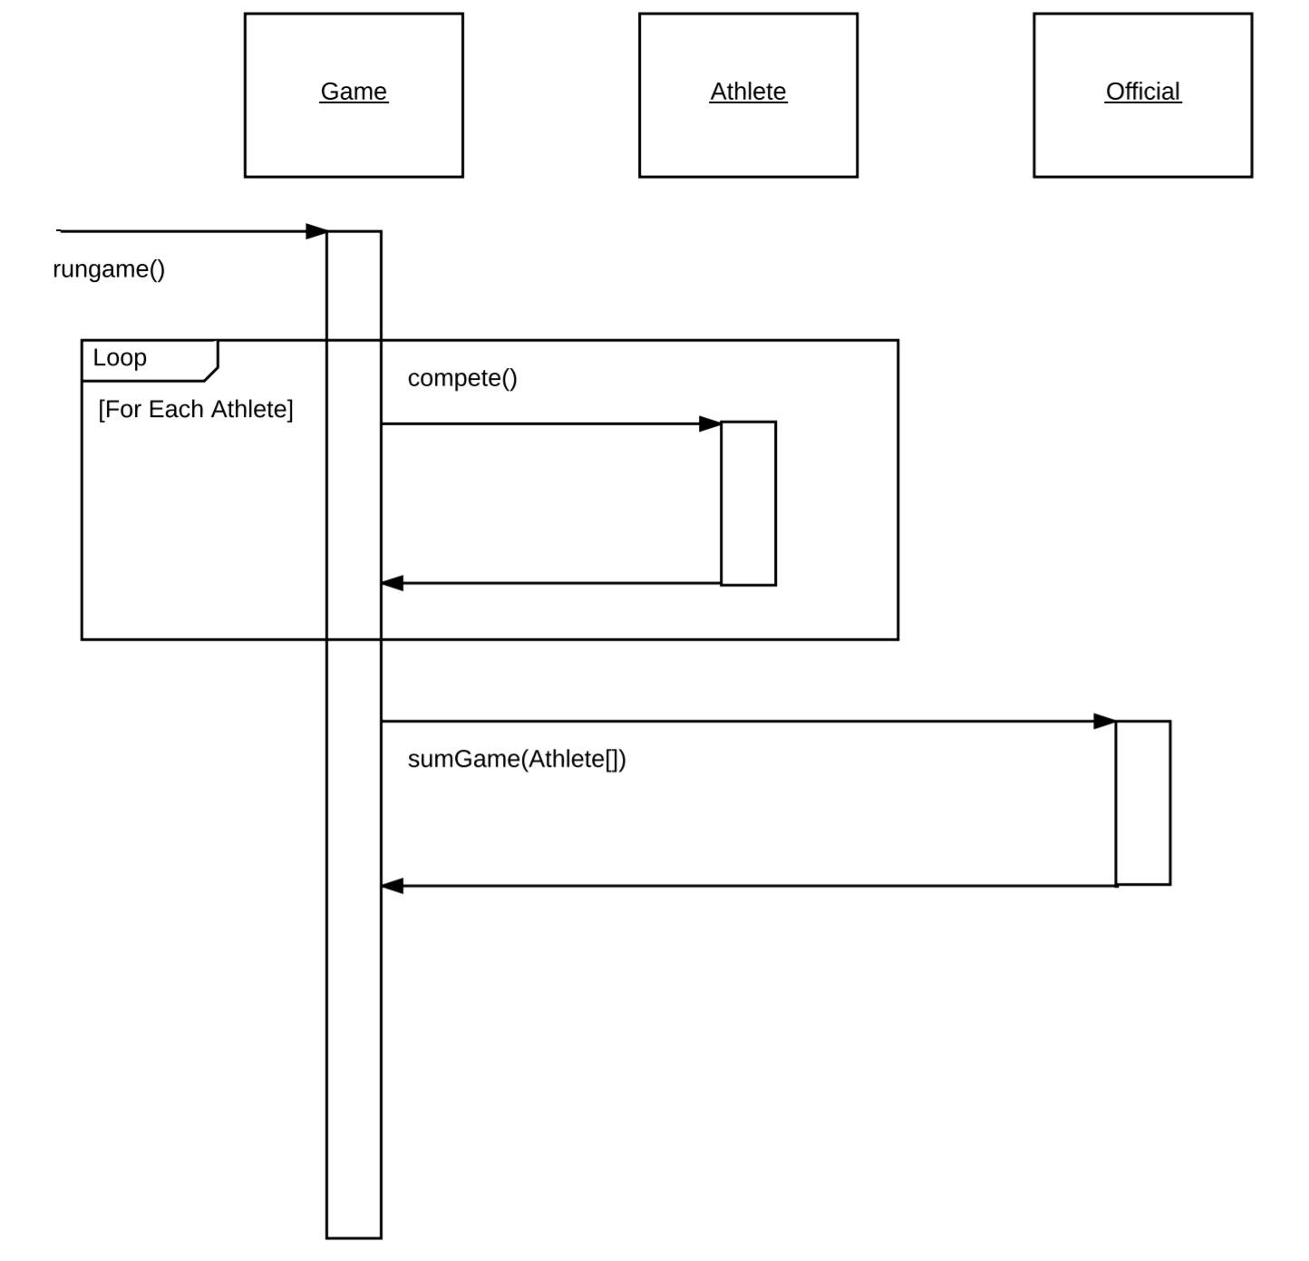

4. Explain how a user prediction can be checked with the actual game results

The user prediction is stored in the game object, after the game is run, the athlete ID is compared against the athlete with the least time.